MEMORANDUM
To: Governor of Massachusetts
From: Shashwat
Date: September 16, 2026
Re: Homelessness in Massachusetts, 2007–2025 — a level break, not a rising trend

Question and why it matters
Has homelessness in Massachusetts risen steadily over the past two decades, or did something discrete happen recently? The distinction carries different policy responses. A gradual rise tracking housing costs points to supply and subsidy instruments. A sudden level shift in a state with a statutory right to shelter for families points instead to intake capacity, eligibility rules and surge financing. Massachusetts is one of only three U.S. jurisdictions guaranteeing shelter, so the question is live rather than academic.
Data and unit of observation
US Department of Housing & Urban Development (HUD) Point-in-Time (PIT) counts, published in the 2025 Annual Homelessness Assessment Report, Part 1 (huduser.gov). The unit of observation is a state-year: a single count of people experiencing homelessness on one night each January. That yields 19 annual observations for Massachusetts, 2007–2025, each broken down by shelter status (sheltered / unsheltered), household type (in families / individuals), chronicity and veteran status. Rates use Census Bureau state population estimates as denominators.
Analysis
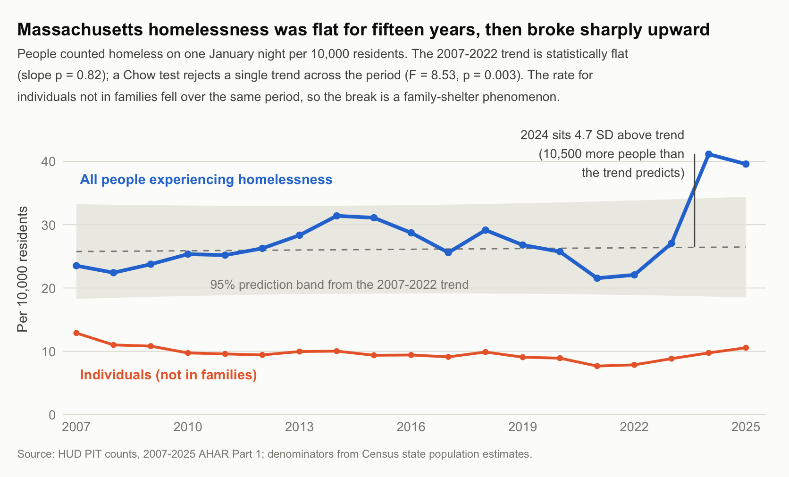
The count rose from 15,127 in 2007 to 28,311 in 2025 — up 87%, or 68% per capita (23.5 to 39.6 per 10,000 residents). That headline conceals the structure. Across 2007–2022 the rate averaged 26.1 per 10,000 (Standard Deviation in 3.0, range 21.6–31.4) with no direction at all. Almost the entire increase arrives in two years: the count rose 89% from 2022 to 2024 (15,507 to 29,360), then eased to 28,311 in 2025. I have decomposed the increase in 13,853 homeless people below:
• People in families: increased by 12,418, which contributed to 89.6% of the increase
• Sheltered: Increased by 13,353, which amounts to 96.4% of the increase
• Chronically homeless individuals: increased by a meagre 426, which accounts for 3.1% total increase
• Veterans: increased by 16, proportionate to 0.1% increase
Two further facts sharpen this. Homelessness among individuals not in families fell over the full period, from 12.9 to 10.6 per 10,000, which is a statistically significant decline (−0.12 per 10,000 per year, p = 0.006). Massachusetts remains almost entirely sheltered as 6.2% of its 2025 count was unsheltered against 35.7% nationally, the second-lowest share among 54 states and territories, behind only New York. The interesting fact is that both states have a large right-to-shelter jurisdiction.
Testing trend against break
Because the question is precisely whether the series follows a trend or shifts level, I fit a linear trend to 2007–2022 only (n = 16) and tested the later years against it. This is a description of the series' structure, not a causal model, and it is reported as such.
The pre-2023 slope is +0.04 per 10,000 per year (SE 0.17; p = 0.82; R² = 0.004): year explains essentially none of the variation, so the earlier period is flat rather than merely slow-rising. Extrapolating that trend predicts 26.4 per 10,000 for 2024. The actual value is 41.1 — outside the interval, 4.7 residual standard deviations above the prediction, about 10,500 more people than the trend implies. A Chow test rejects a single trend across the period (F(2,15) = 8.53, p = 0.003). Note that 2023 itself (27.1) falls inside the band: the break is 2024, not 2023.
Analysis Results Interpretation
Following things are supported by these data. Firstly, Massachusetts had no detectable upward trend in homelessness from 2007 to 2022, so the common framing that homelessness has been rising for the decade does not fit this state. Secondly, the increase is a discrete level shift in 2024, distinguishable from trend at conventional significance. Thirdly, data shows that families are overwhelmingly entering shelter, while chronic and individual homelessness were close to unaffected.
Facts not established by the data. The cause of the sudden increase in homelessness is unexplained. The timing coincides with large asylum-seeker arrivals meeting the state's right-to-shelter obligation, and the 2025 decline follows tightened Emergency Assistance eligibility. However, a single-state series of 19 points cannot attribute the break to either. Doing so would require a comparison group (other states, or the other right-to-shelter jurisdictions) and covariates for housing costs, mortgage rates, and labour markets. Separately, a right-to-shelter system converts hidden homelessness into counted and sheltered homelessness, so part of the measured rise may reflect enrolment in a system rather than new hardship. The HUD PIT data cannot separate the two.
Measurement limits. PIT data captures one January night and so misses episodic homelessness across the year (AHAR Part 2 annual counts would be needed). Unsheltered figures rest on street canvasses with a known undercount, so year-to-year movements in that series are the least reliable component. Population denominators splice three Census vintages (2000–2010 intercensal, Vintage 2020, Vintage 2025), introducing small discontinuities at the 2010 and 2020 boundaries.

Sources. HUD, 2025 AHAR Part 1, PIT Counts by State 2007–2025 (huduser.gov/portal/datasets/ahar). U.S. Census Bureau, State Population Totals (NST-EST2025, nst-est2020, st-est00int). Analysis in R; scripts and the extracted Massachusetts series accompany this memo.

